|  |  |  |  |  |  |  |
| --- | --- | --- | --- | --- | --- | --- |
| Name: | | | ___________________________________________ | | Date: *______* | |
| pact jpg1  **Time allowed:**  **Reading**  **Working** | | | **Subject: METHODS MAT**  **Investigation 4, 2015**  **Topic: Trigonometrical Functions**  5 mins  55 mins | | 47  = % | |
| **Weighting:** | | | *5% of the year.* | | |  |
| **Equipment:** | | | *Curriculum Council, Formula sheets, Calculators* | | | |
| **Important Information:**  *This in-class validation will be completed under test conditions.*  ***Answers should be rounded appropriately****. All working should be shown in the space provided. Your working should be in sufficient detail to allow your answers to be checked readily and for marks to be awarded for reasoning. Incorrect answers given without supporting reasoning cannot be allocated any marks. For any question or part question worth more than two marks, valid working or justification is required to receive full marks.*  *No pen, pencils, highlights etc. may be used during reading time. This time is to be used to read through the assessment and check that you understand what is being asked of you. You may speak with the teacher/supervisor during this time (by putting up your hand and waiting patiently for them to approach you) but you may only ask clarification questions and not how to solve the problems. After reading time has ended, you may not ask any more questions.* | | | | | | |
|  |  |  | |  | | |

**Question 1 (9 marks:2,2,2,3)**

Use your CAS calculator to draw and compare the following graphs in the domain 

(a) Compare the graphs of  and .

Comment on,

1. the graphs
2. the two functions,  and

(b) Compare the graphs of  and .

Comment on your observations.

(c) Now, compare the graphs of  and .

Comment on your observations.

(d) State a generalisation of the above observations connecting  and .

**Question 2 (13 marks:2,3,3,2,3)**

1. On the axes below, a sketch of the graphs of  and  for , is provided. State the period and amplitude of each graph.

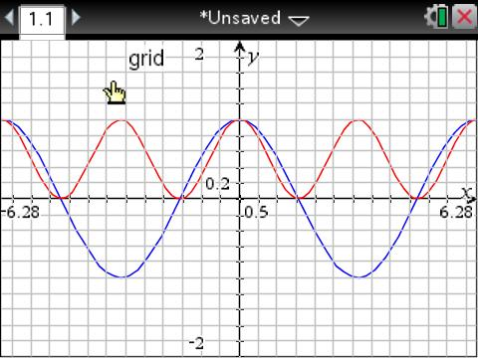

Note 

1. On the same set of axes, draw a sketch of , using a different colour.

Note: 

1. Now add the *y* values of each of the graphs of  and  together to produce the graph of  (again, use a different colour).
2. State the amplitude and period of the graph of 
3. State an equivalent equation for the graph of  in the form .

**Question 3 (17 marks:2,2,3,2,4,4)**

1. Sketch the graph of  for

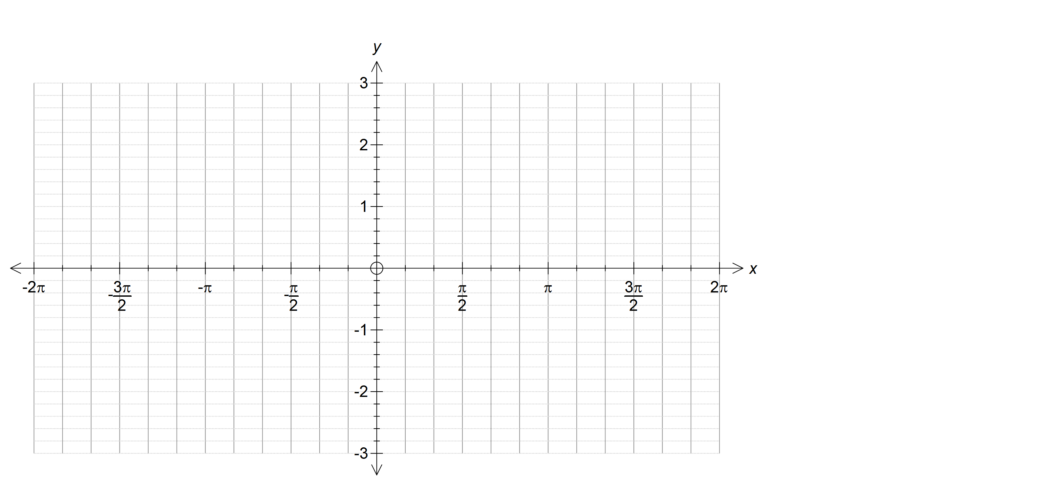

(b) On the same set of axes, draw a sketch of, using a different colour

(c) Add the ordinates (y values) of the two graphs to produce a sketch of (use a different colour)

(d) State the amplitude and period of the graph of 

1. Use your graph to state an equivalent equation for the graph of in the form of 

(f) Graph the function y = 3cos x – 4sin x on your calculator. Hence, state an equivalent function in the form



**Question 4 (8 marks)**

Use your calculator to investigate adding two functions with the same period, such as,  and  to get.

What do you notice about the resulting function? Is it also periodic? State any generalisations that you notice relating to the period, amplitude and/or the phase of the original and the combined functions.

Illustrate your conclusion/generalisations with another example such. Use the axes provided below to illustrate your example.

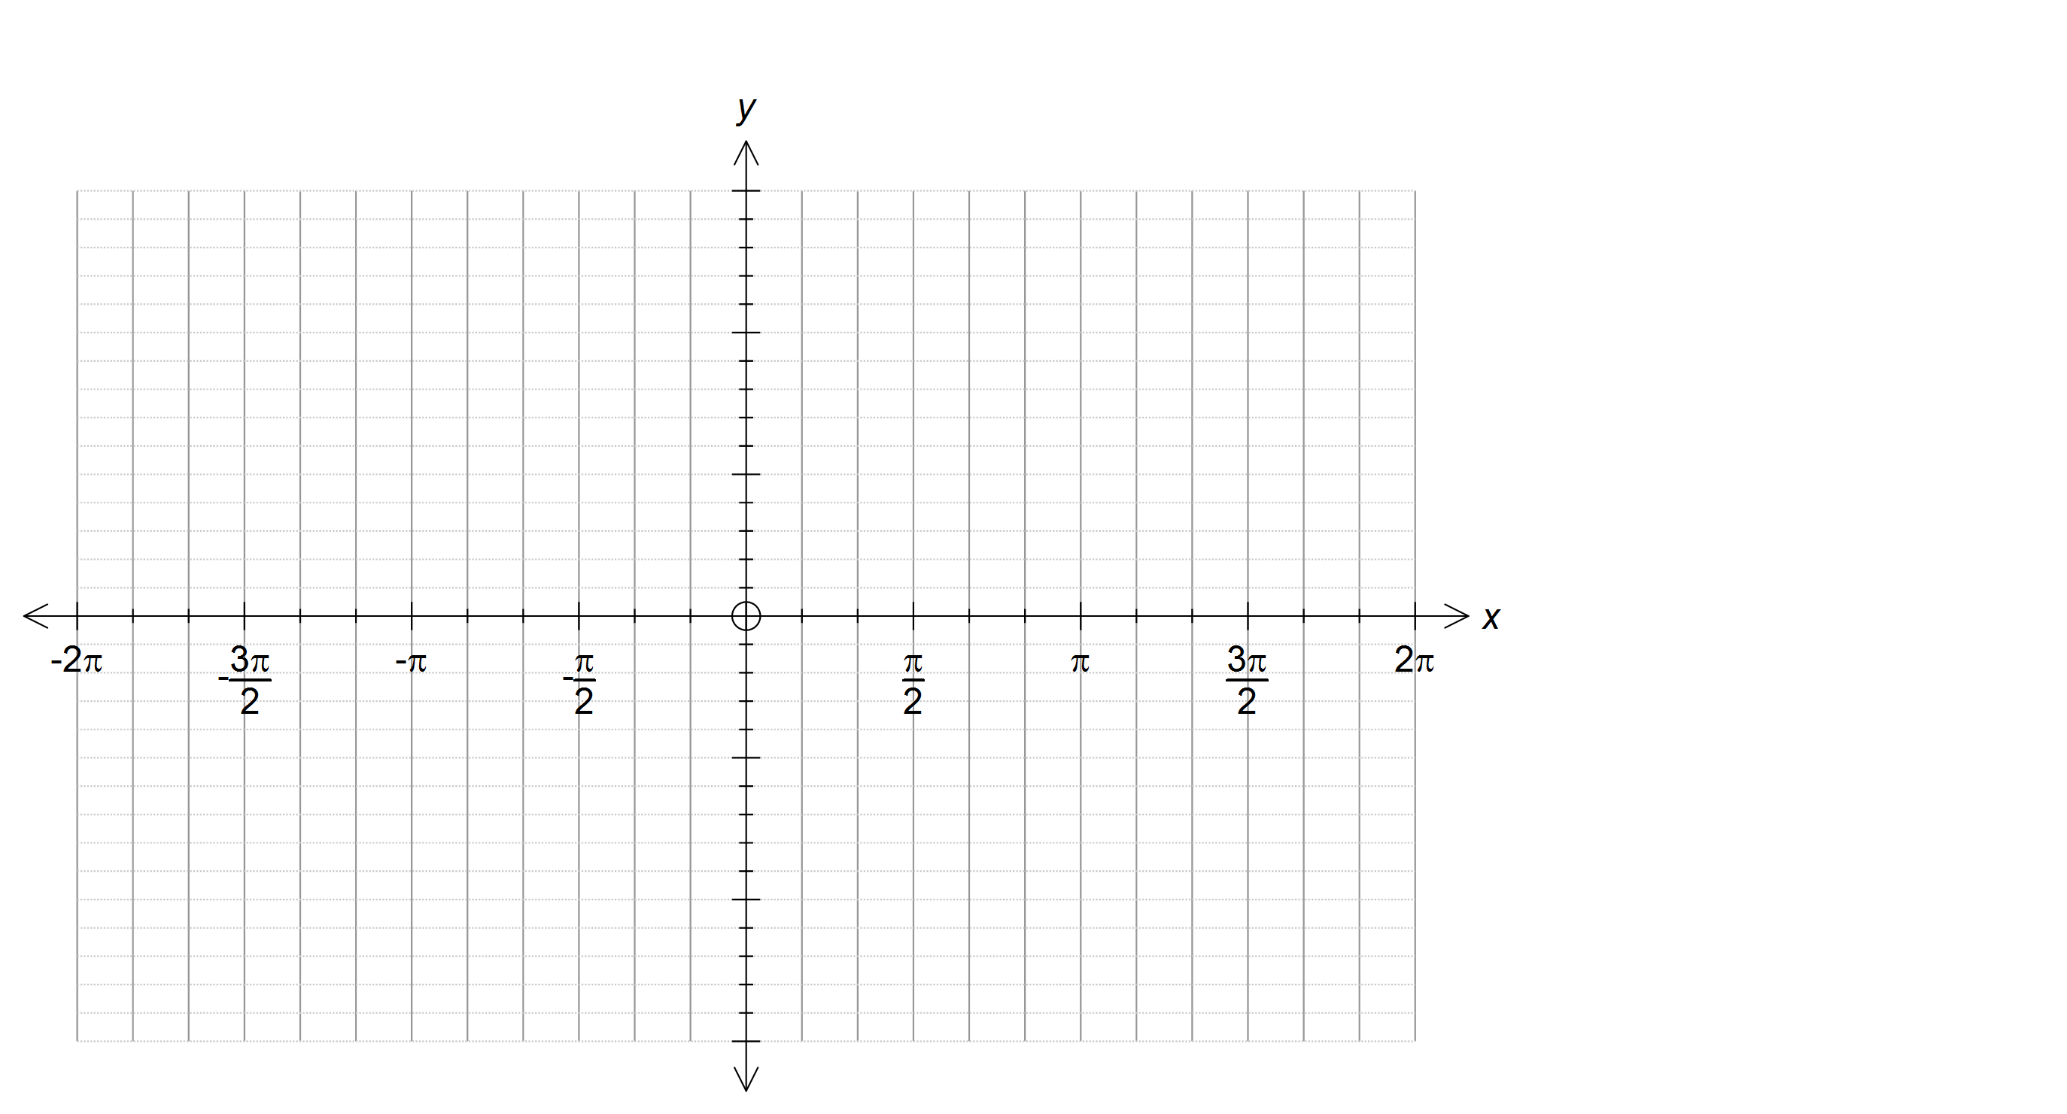

|  |  |  |  |
| --- | --- | --- | --- |
| Name: | _______SOLUTIONS____________________________________ | Date: *______* | |
| pact jpg1  **Time allowed:**  **Reading**  **Working** | **Subject: METHODS MAT**  **Investigation 4, 2015**  **Topic: Trigonometrical Functions**  5 mins  55 mins | 47  = % | |
| **Weighting:** | *5% of the year.* | |  |
| **Equipment:** | *Curriculum Council, Formula sheets, Calculators* | | |
| **Important Information:**  *This in-class validation will be completed under test conditions.*  ***Answers should be rounded appropriately****. All working should be shown in the space provided. Your working should be in sufficient detail to allow your answers to be checked readily and for marks to be awarded for reasoning. Incorrect answers given without supporting reasoning cannot be allocated any marks. For any question or part question worth more than two marks, valid working or justification is required to receive full marks.*  *No pen, pencils, highlights etc. may be used during reading time. This time is to be used to read through the assessment and check that you understand what is being asked of you. You may speak with the teacher/supervisor during this time (by putting up your hand and waiting patiently for them to approach you) but you may only ask clarification questions and not how to solve the problems. After reading time has ended, you may not ask any more questions.* | | | |

**Question 1**

|  |  |  |
| --- | --- | --- |
| (a) | Solution | |
|  | The two graphs are identical  the two functions are equal  i.e. | |
| Mathematical behaviours | | Marks |
| * States that the two graphs are identical * Concludes that the two functions are equal | | 1  1 |
|  | | |
| (b) | Solution | |
|  | The two graphs are identical  the two functions are equal  i.e. | |
| Mathematical behaviours | | Marks |
| * States that the two graphs are identical * Concludes that the two functions are equal | | 1  1 |
|  | | |
| (c) | Solution | |
|  | The two graphs are identical  the two functions are equal  i.e. | |
| Mathematical behaviours | | Marks |
| * States that the two graphs are identical * Concludes that the two functions are equal | | 1  1 |

**Question 1 (continued)**

|  |  |  |
| --- | --- | --- |
| (d) | Solution | |
|  |  | |
| Mathematical behaviours | | Marks |
| * Indicates the amplitude connection (i.e. ) * Indicates the correct frequency/period connection (i.e. ) * States the appropriate double angle rule | | 1  1  1 |

**Question 2**

|  |  |  |
| --- | --- | --- |
| (a) | Solution | |
|  | : Amplitude =1, period =  : Amplitude =, period = | |
| Mathematical behaviours | | Marks |
| * States the correct period and amplitude for * States the correct amplitude for * States the correct period for | | 1  1  1 |
|  | | |
| (b) | Solution | |
|  |  | |
| Mathematical behaviours | | Marks |
| * Graph reflects the correct period and amplitude * Graph is in the correct position i.e. below  axis * Graph has ‘good’ shape, appropriately rounded turning points | | 1  1  1 |
|  | | |

|  |  |  |
| --- | --- | --- |
| (c) | Solution | |
|  |  | |
| Mathematical behaviours | | Marks |
| * Adds the ordinates of the correct two graphs * Graph reflects the correct period and amplitude * Graph is in the correct position * Graph has ‘good’ shape, with appropriately rounded turning points | | 1  1  1  1 |
|  | | |
| (d) | Solution | |
|  | Amplitude =1, period = | |
| Mathematical behaviours | | Marks |
| * States the correct amplitude * States the correct period | | 1  1 |
|  | | |
| (e) | Solution | |
|  |  | |
| Mathematical behaviours | | Marks |
| * Identifies that it is a cosine function * Determines * Determines *a* = 1 | | 1  1  1 |

**Question 3**

|  |  |  |
| --- | --- | --- |
| Solution | | |
| (a)&  (b) |  | |
| Mathematical behaviours | | Marks |
| * Sketches the correct sine function with amplitude = and period = * Shape of graph is ‘good’ with appropriately rounded turning points * Sketches the correctly reflected cosine function with amplitude =1 and period = * Shape of graph is ‘good’ with appropriately rounded turning points | | 1  1  1  1 |
|  | | |
| (c) | Solution | |
|  |  | |
| Mathematical behaviours | | Marks |
| * Shows evidence of adding the correct ordinates * Graph has ‘good’ shape, appropriately rounded turning points * Turing points are roughly in the correct position | | 1  1  1 |
|  | | |
| (d) | Solution | |
|  | Amplitude = 2 , Period = | |
| Mathematical behaviours | | Marks |
| * States the amplitude =2 * States the period = 2 | | 1  1 |
|  | | |
| (e) | Solution | |
|  | Let  From the graph,  period is  , so  amplitude = 2 , so *A* = 2  phase shift of sine graph is  to the right | |
| Mathematical behaviours | | Marks |
| * Uses the period from the graph to determine * Determines * Determines * Concludes | | 1  1  1  1 |
| (f) | Solution | |
|  |  | |
| Mathematical behaviours | | Marks |
| * Uses the period from the graph to determine * Determines * Determines phase shift of cos x graph is 0.39 * Concludes | | 1  1  1  1 |

**Question 4**

|  |  |
| --- | --- |
| Solution | |
| Drawing the respective graphs, give the results below.    So, yes the function is periodic, with a period of  . The amplitude of is greater than the amplitude of either of the two individual functions but less than the sum of the amplitude of the two functions i.e. 1<amplitude<2 and the phase shift of y = cos 2x is 0.39 to the right    Another example is    The function is periodic with period =  , amplitude = 1.41 and the phase shift of  from the graph is 1.57 () to the right, so equation the is | |
| Mathematical behaviours | Marks |
| * Sketches and labels at least two graphs with different periods * Determines that the sum of the two functions is periodic and states the   correct period for each graph   * Makes ‘simple’ statement about the amplitude for each graph * States an appropriate phase shift for either the sine or the cosine version   of at least one of the resultant graphs   * States the equation of the sum using sine or cosine for at least one   graph | 2  2  2  1  1 |